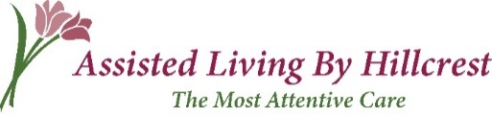

Assisted Living By Hillcrest and Caraton Commons is very excited to announce our partnership with PRN Home Health & Therapy. PRN is locally owned and offers a full spectrum of Physical, Occupational and Speech Therapy services. Our goal is to keep your loved one stronger and healthier which will allow them to live safely and more independently.

PRN will have a dedicated therapy space with a variety of exercise equipment providing our residents traditional therapy in the comfort of their home. As a Home Health Agency and a Rehab Agency, they can see residents under their Medicare A benefit or Medicare B benefit, and can transition from one to the other. Under Med A benefits, they can also see residents for any skilled nursing need, such as post-surgical care, wound care, diabetes management, medication teaching and care for chronic illnesses & injuries. PRN’s dedicated staff verifies all of your benefits ahead of time and is always available to answer any questions.

The Directors of each facility will work alongside the PRN therapy team, as well as the physician, to determine when therapy is needed. PRN can provide therapy to improve strength, range of motion, endurance, coordination, increase independence in activities of daily living, maximize communication & cognitive skills, enhance swallowing ability, and help aid in adjustments to hearing loss. They also offer a number of additional certifications including LSVT BIG & LOUD for Parkinson’s Disease and Lymphedema management.

PRN’s therapy team will be offering free therapy screens to all our residents and will continue to monitor for any residents experiencing a decline. Additionally, Assisted Living By Hillcrest and Cartaton Commons will work with PRN to provide education & teaching to residents, families and staff.

We are truly looking forward to the wonderful opportunities PRN will bring to Assisted Living By Hillcrest and Caraton Commons. There is no place like home and we are grateful to PRN for coming into our facilities and providing exceptional therapy for our family.

